|  |  |  |
| --- | --- | --- |
| **CURRICULUM VITAE** | **2017** | |
| *Result-oriented Professional in pursuit of challenging and enriching assignments in* ***M.A in Clinical Psychology with 1 years experience of Counseling*** *with an organization of high repute* | |  |

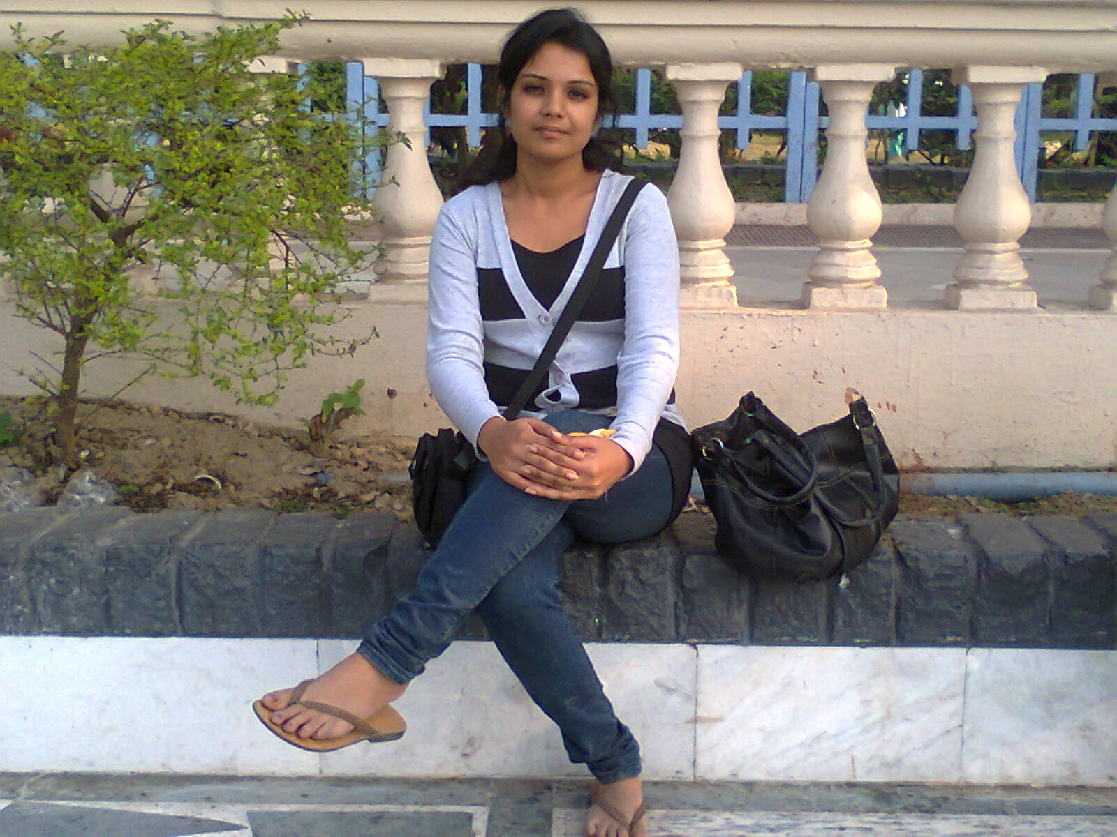ABANTIKA PAUL DEBNATH

Contact Nos.:7209149741/ 08981083289 ~ E-Mail: [**abantikasonai@yahoo.com**](mailto:abantikasonai@yahoo.com)

**PROFILE SUMMARY**

* **Dynamic Professional** with **over 1 years (Since December, 2015- January, 2016)** of experience in:
* ***Counseling***
* ***Training***
* ***Teacher***
* ***Supervising***
* ***Research***
* ***Negotiation***
* ***Supporting***
* ***Presentation***
* ***Microsoft Office***
* ***Manpower Management***
* ***Career Counseling***
* ***Formation of peer groups & child protection committee.***
* ***Interview & home visit***
* ***Motivate children and parents***
* ***School orientation***
* ***CG (Children’s group )& CPC( Child Protection Committee meeting***
* ***Problem solving***
* ***survey***
* Counseling to children and parents.
* Career Counseling to students.
* Psychological counseling to children and adults.
* Comprehensive Life Skill training to children.
* Organized Campaign, Home visit and interview of children and parents.
* Formation and training Peer groups, children’s group and Child Protection Committee.
* Evaluating **Multipurpose Activity Center( MAC)**
* Liaison with local club members, councilors, schools.
* Liaison with vocational training institutes & supervising vocational training program and also organizing events and public gathering.
* Meeting with Children’s group and Child Protection Committee.
* To give orientation about Vocational training at Clubs, Schools, Children and parents.
* To give orientation about need of school to Child **Domestic Workers and Child Labors** and parents.
* To survey in different areas in Kolkata and Howrah for find out child domestic workers and child labor for vocational training and also for giving a school support.
* To give a teaching support to primary and secondary and college students ( mainly psychology students )

**AREAS OF EXPERTISE**

* *Counseling, psychological counseling, Parents counseling and Career counseling.*
* *To give a mental support to patient and parents.*
* *Interview and home visit.*
* *To motivate patient and their parents.*
* *To give a teaching support to primary and secondary and college students.*

**AREAS OF SPECIALIZATION**

* Clinical Psychology.
* Psychological counseling of children and adult
* Career counseling of children and adult
* Parents counseling

**WORK EXPERIENCE**

1. **Since Jan 2015 to Jan 2016 with Development Action Society, Gariahat, Kolkata,**

**Counseling, Psychological counseling & Career counseling.**

**Project Handled:**

**Title: Protecting & Empowering Child Domestic Workers across three states in India**

**Supported by Save the Children**

**Period: - Jun, 2014- Feb, 2017**

**Role: Counselor**

**Nature & Scope of Responsibility:**

* Children’s and Parent’s counseling, career counseling and also supervising the project**.**
* To give a counseling support to those child domestic workers and child labors (6-15 years) who give up from school or irregular at school, and vocational trainees who are irregular at training institutes or give up the training program in the middle of the training, or those candidates who are not interested in job after completion of training and also drug addicted and those who are psychologically ill.
* After completion of counseling session following up every candidates through home visit for taking information about their present condition.
* Preparing a PPT of our project (including vocational training) for giving an orientation to children, parents, club members, CPC & CG members, and school.
* Organizing campaign (auto campaign, street kiosk, talking doll show etc) for giving an orientation about the project to Domestic children, child labor and parents. And also another individuals in that area.
* Interview and home visit of children.
* Supervising vocational training program.
* To make a monthly report of Counseling.
* To Control and handle Driving batch, weekly visit to diving institutes for observing their training, behavior of driving master’s toward our children, and also for taking report from the children about the institutes and also from the owner of the institutes about our children. And also after completion of the training of hand over driving licenses to candidates.
* Weekly follow up candidates of vocational training. (Both who pursuing the training and who doing a after completing the training)
* Weekly follow up to every training institutes for taking reports from institution about candidates.
* To survey in different areas in Kolkata and Howrah for find out child domestic workers and child labor for giving a job support through vocational training and a free school support.
* Organizing meeting with Club members, CPC (Child Protection Committee), CG groups and also with parents for giving an orientation about our project. Apart from this also given an orientation about eve teasing, good touch and bad touch, disadvantages of drug, child marriage , corporal punishments, physical torture, disadvantages of child domestic work and child labor, need of education, etc for empowering them.

1. **Since Jun 2012 to Jan 2016 Private tuition of school and college students .( main focus psychology students)**
2. **Since December 2014to Jan 2016 counseling in *Care & Cure polyclinic cum Nurshinghome***

**Nature & Scope of Responsibility:-**

* Counselling of patient of both children and adult.
* Career counselling.
* Parent’s counselling.
* Submission of reports to patient party after completion of counselling session.

**TRAININGS RECEIVED**

* Lalita & Babu in 2015
* Psychological counseling in 2014
* Life skill training in 2015
* Training on Lesson plan, report writing, attendance book in 2015
* Effective Communication Skill
* Presentation Skill

**Workshop attends:**

* Internship training from Bangur Institute of Neuroscience (S.S.K.M) in the year of 2014.
* Training of career advisor from NICE (pursuing).
* Counselling training from UMID in the year of 2011.

**SYNOPSIS**

**Measuring differentiate between stress and anxiety among men and women after retirement in Kolkata.**

**ITS SKILLS**

* Well versed with MS Office (Project, Word, Excel and PowerPoint), Internet Applications

**ACADEMIC DETAILS**

* The Matriculation examination in the year of 2007 from Santragachi Kedernath Institution For Girl’s under the W.B.B.S.E with 62.13%, ( 1st division )
* The higher secondary examination (H.S) in the year of 2009 from Santragachi Kedernath Institution For Girl’s under the W.B.C.H.S.E with 61.75% ( 1st division )
* The Graduation (B. sc) from Bangabasi College under Calcutta University year of 2012 with 50%. ( 2nd class )
* M.A in Clinical psychology from IGNOU with 59.38% in the year 2014. ( 2nd class )

**PERSONAL DETAILS**

* **Date of Birth:** The 18th September, 1991
* **Husband’s name:** Narayan Debnath
* **Permanent address:** Ramrajatala, Sastitala Kona Road, Howrah-711104
* **Residential address:** 1/5 chandrakumar banerjeelane , Shibpur, Howrah-711102
* **Religion:** Hindu
* **Nationality**: Indian
* **Status:** married
* **Area of Interest**: Dancing.
* **Hobbies**: Reading story book
* **Languages known**: Bengali, Hindi, English

***I hereby declare that the information given above are true and correct to the best of my knowledge and belief.***

**Dated: Place: Kolkata signature**

**ABANTIKA PAUL DEBNATH**